**Sprint 1**

|  |  |
| --- | --- |
| **DATE** | **16 november 2022** |
| **TEAM ID** | **PNT2022TMID45918** |
| **PROJECT NAME** | **IOT BASED SMART CROP PROTECTION FOR**  **AGRICULTURE** |
| **MAXIMUM MARK** | **20 MARKS** |

# PROGRAM:

#include LiquidCrystal lcd(13,12,6,5,3,2); int led=7;

int PIR=4;

int buzzer=8; int PIRstatus; void setup()

{

lcd.begin(16,2); pinMode(led, OUTPUT); pinMode(buzzer, OUTPUT); pinMode(PIR, INPUT); lcd.clear();

}

void loop()

{

PIRstatus=digitalRead(PIR); if (PIRstatus==HIGH)

{

lcd.clear();

}

void loop()

{

PIRstatus=digitalRead(PIR); if (PIRstatus==HIGH)

{

lcd.clear(); digitalWrite(led, HIGH);

digitalWrite(buzzer, HIGH); digitalWrite(buzzer, HIGH); tone(buzzer, 300, 10000); lcd.setCursor(0,1); lcd.print("ALERT"); delay(7000);

lcd.clear();

}

else

{

lcd.setCursor(0, 0); lcd.print("SAFE"); digitalWrite(led, LOW); digitalWrite(buzzer, LOW);

}

delay(1000);

}

# OUTPUT:

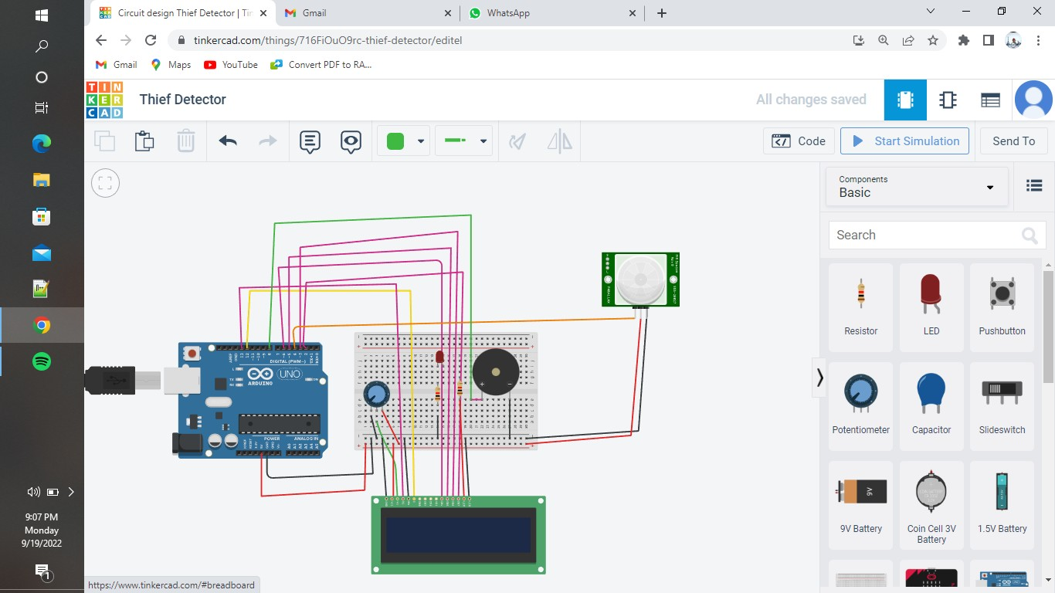

**PURPOSE:**

This will be used to sense tha animal or any other object through the sensor and it will connect to the arduino . Any animal or object they will start up to alarm sound and the LED will be on.